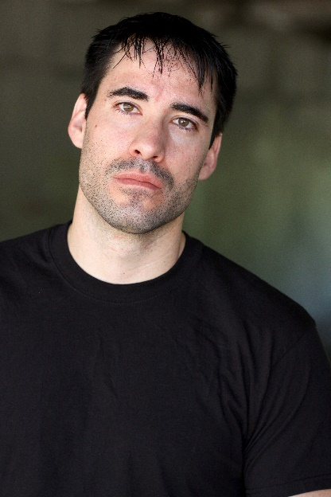**Craig Beeman**

Height: 6’ Cell: 505-918-5331

Weight: 190 Email: [craigbeeman21@gmail.com](mailto:craigbeeman21@gmail.com)

Hair: Brown 9208 Jill Patricia NW

Eyes: Brown Albuquerque, NM 87114

Caucasian

**____________________________________________________________________________**

**FILM**

Charles, Lead “Tainted Love” CMI (2017)

Steve, Lead “Suicide Diaries” No.25 Studio (2017)

Natas, Supporting Role “Devil in the City of Crosses” Knockout Features(2017)

Brad, Lead “The Trail” CMI (2015)

Jim Pater, Lead “Knock ‘Em Dead” CMI (2015)

Brayden, Lead “Foreseeable” Reelflicks Prod. (2014)

Mike, Supporting Role “Close Enough to Perfect” Tecolote Films (2011)

Will Freeman, Lead “Bomb Squad” Desert Strm. Prod.(2011)

Dad, Lead “Daddy” T-Ro Films (2009)

Harry, Lead “Mob Snacks” Desert Strm Prod. (2009)

Various Roles “Cru 2009” T-Ro, Desert Strm.(2009)

Jordan, Supporting Role “Santisma Muerte” T-Ro Films (2008)

Philip, Supporting Role “Forget Me Not” Reelflicks Prod. (2007)

**TRAINING**

Glorietta Drama Conference (2005) Santa Fe, NM

“Subtext” Workshop by Hannah Macpherson (2010) Albuquerque, NM

Price Hall Acting Workshop (2011) Albuquerque, NM

Price Hall Acting Workshop (2012) Albuquerque, NM

ABQ Actors’ Studio (2017) Albuquerque, NM

**SPECIAL SKILLS**

Football, Writing, Athlete, Driving Manual Transmission, Public Speaking, School Teacher